1-Git

🧠 What Is Git?
# Source: AI Source: Provided by: [Data Path: Persons Table -> ID Column: 1, Name_En Column: Motasem Essam] -> From: [ChatGPT] on [2/16/2026]
Git is a distributed version control system (DVCS) that helps developers track changes in code, collaborate with others, and manage multiple versions of a project efficiently.

🧰 In Simple Terms:
# Source: AI Source: Provided by: [Data Path: Persons Table -> ID Column: 1, Name_En Column: Motasem Essam] -> From: [ChatGPT] on [2/16/2026]
Git is like a smart "save system" for your code — it remembers every change, lets you go back, and lets teams work safely on the same project.

✅ What Git Can Do:
# Source: AI Source: Provided by: [Data Path: Persons Table -> ID Column: 1, Name_En Column: Motasem Essam] -> From: [ChatGPT] on [2/16/2026]
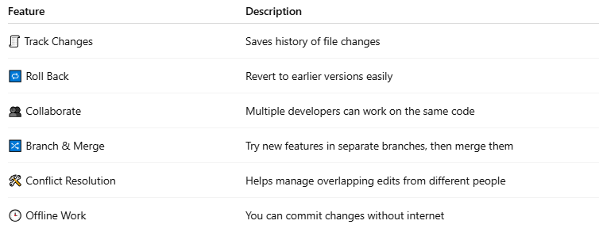

Feature | Description
🧾 Track Changes | Saves history of file changes
🔁 Roll Back | Revert to earlier versions easily
👥 Collaborate | Multiple developers can work on the same code
🔀 Branch & Merge | Try new features in separate branches, then merge them
🛠 Conflict Resolution | Helps manage overlapping edits from different people
🕒 Offline Work | You can commit changes without internet

🛠 Git vs GitHub:
# Source: AI Source: Provided by: [Data Path: Persons Table -> ID Column: 1, Name_En Column: Motasem Essam] -> From: [ChatGPT] on [2/16/2026]
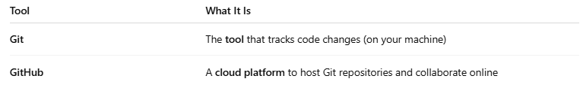

Tool | What It Is
Git | The tool that tracks code changes (on your machine)
GitHub | A cloud platform to host Git repositories and collaborate online

🧪 Basic Git Workflow
# Source: AI Source: Provided by: [Data Path: Persons Table -> ID Column: 1, Name_En Column: Motasem Essam] -> From: [ChatGPT] on [2/16/2026]
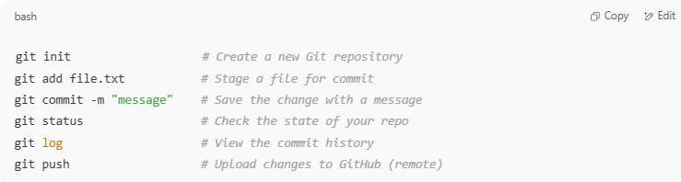
git init # Create a new Git repository
git add file.txt # Stage a file for commit
git commit -m "message" # Save the change with a message
git status # Check the state of your repo
git log # View the commit history
git push # Upload changes to GitHub (remote)

📂 Git Repository
# Source: AI Source: Provided by: [Data Path: Persons Table -> ID Column: 1, Name_En Column: Motasem Essam] -> From: [ChatGPT] on [2/16/2026]
A repository (repo) is a folder that Git tracks. It contains:
- Your project files
- A hidden .git folder with all history and metadata

📜 Example Use Case
# Source: AI Source: Provided by: [Data Path: Persons Table -> ID Column: 1, Name_En Column: Motasem Essam] -> From: [ChatGPT] on [2/16/2026]
You’re building a PHP project:
- You git init to start version control.
You write index.php and commit it:
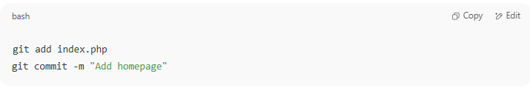
git add index.php
git commit -m "Add homepage"

- You change the file, commit again.
- You can now:
  - See the entire edit history
  - Revert to the first version
  - Share it on GitHub

🔀 Git Branches
# Source: AI Source: Provided by: [Data Path: Persons Table -> ID Column: 1, Name_En Column: Motasem Essam] -> From: [ChatGPT] on [2/16/2026]
Branches let you:
- Work on new features separately
- Avoid breaking your main code
- Merge changes later
Example:
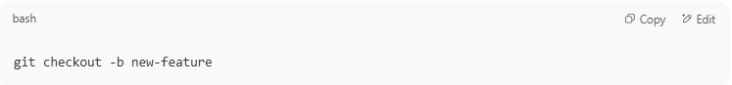
git checkout -b new-feature

🔧 Git Tools (optional GUIs)
# Source: AI Source: Provided by: [Data Path: Persons Table -> ID Column: 1, Name_En Column: Motasem Essam] -> From: [ChatGPT] on [2/16/2026]
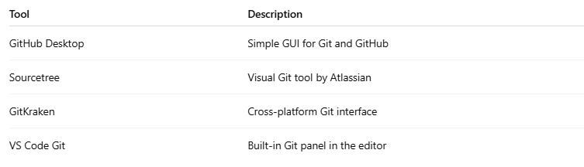

Tool | Description
GitHub Desktop | Simple GUI for Git and GitHub
Sourcetree | Visual Git tool by Atlassian
GitKraken | Cross-platform Git interface
VS Code Git | Built-in Git panel in the editor

🧠 Summary
# Source: AI Source: Provided by: [Data Path: Persons Table -> ID Column: 1, Name_En Column: Motasem Essam] -> From: [ChatGPT] on [2/16/2026]
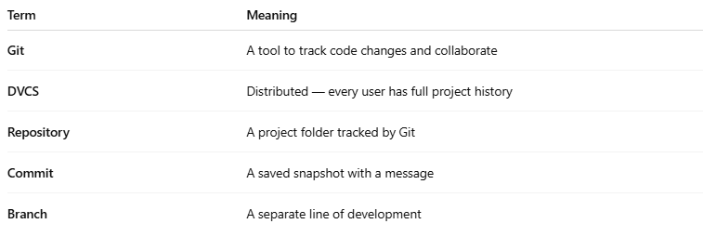

Term | Meaning
Git | A tool to track code changes and collaborate
DVCS | Distributed — every user has full project history
Repository | A project folder tracked by Git
Commit | A saved snapshot with a message
Branch | A separate line of development

2-GitHub

🐙 What Is GitHub?
# Source: AI Source: Provided by: [Data Path: Persons Table -> ID Column: 1, Name_En Column: Motasem Essam] -> From: [ChatGPT] on [2/16/2026]
GitHub is a web-based platform that lets developers:
- Store their Git repositories online
- Collaborate with others
- Track code changes
- Review and manage open-source or private projects
✅ Git = the tool
🌐 GitHub = the online service for sharing and managing Git projects

🧠 In Simple Terms:
# Source: AI Source: Provided by: [Data Path: Persons Table -> ID Column: 1, Name_En Column: Motasem Essam] -> From: [ChatGPT] on [2/16/2026]
GitHub is like Google Drive for code, but with superpowers for developers:
- You push your Git code to GitHub
- Teammates can clone it, suggest changes, or report bugs

🔧 What GitHub Offers:
# Source: AI Source: Provided by: [Data Path: Persons Table -> ID Column: 1, Name_En Column: Motasem Essam] -> From: [ChatGPT] on [2/16/2026]
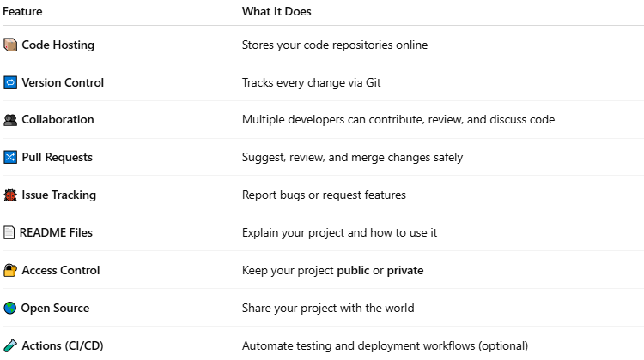

Feature | What It Does
📦 Code Hosting | Stores your code repositories online
🔁 Version Control | Tracks every change via Git
👥 Collaboration | Multiple developers can contribute, review, and discuss code
🔀 Pull Requests | Suggest, review, and merge changes safely
🐞 Issue Tracking | Report bugs or request features
📄 README Files | Explain your project and how to use it
🔐 Access Control | Keep your project public or private
🌎 Open Source | Share your project with the world
🧪 Actions (CI/CD) | Automate testing and deployment workflows (optional)

📂 How It Works (Typical Workflow)
# Source: AI Source: Provided by: [Data Path: Persons Table -> ID Column: 1, Name_En Column: Motasem Essam] -> From: [ChatGPT] on [2/16/2026]
- You create a Git project locally:
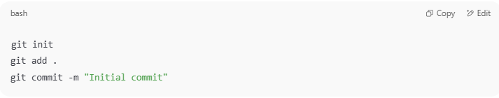
git init
git add .
git commit -m "Initial commit"

- You push it to GitHub:
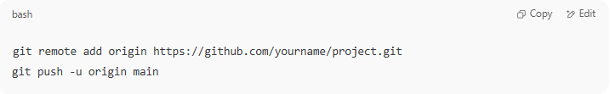
git remote add origin https://github.com/yourname/project.git
git push -u origin main

- On GitHub, others can:
  - 🌱 Fork your project (make a copy)
  - 🔁 Clone it to their machine
  - 📝 Submit a Pull Request to suggest changes
  - 📣 Open issues to report bugs or suggest improvements

👤 GitHub Account
# Source: AI Source: Provided by: [Data Path: Persons Table -> ID Column: 1, Name_En Column: Motasem Essam] -> From: [ChatGPT] on [2/16/2026]
You can sign up for free at: https://github.com
Free accounts include:
- Unlimited public + private repos
- Issue tracking
- GitHub Pages (host static websites)

🛠 GitHub vs Git
# Source: AI Source: Provided by: [Data Path: Persons Table -> ID Column: 1, Name_En Column: Motasem Essam] -> From: [ChatGPT] on [2/16/2026]
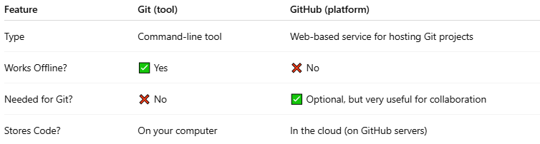

Feature | Git (tool) | GitHub (platform)
Type | Command-line tool | Web-based service for hosting Git projects
Works Offline? | ✅ Yes | ❌ No
Needed for Git? | ❌ No | ✅ Optional, but very useful for collaboration
Stores Code? | On your computer | In the cloud (on GitHub servers)

🧠 Summary
# Source: AI Source: Provided by: [Data Path: Persons Table -> ID Column: 1, Name_En Column: Motasem Essam] -> From: [ChatGPT] on [2/16/2026]
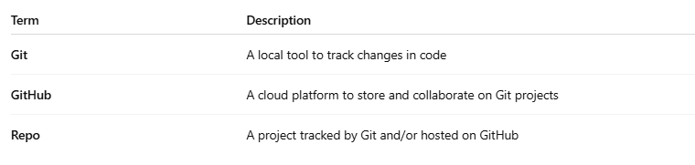

Term | Description
Git | A local tool to track changes in code
GitHub | A cloud platform to store and collaborate on Git projects
Repo | A project tracked by Git and/or hosted on GitHub

3-GitLab

🦊 What Is GitLab?
# Source: AI Source: Provided by: [Data Path: Persons Table -> ID Column: 1, Name_En Column: Motasem Essam] -> From: [ChatGPT] on [2/16/2026]
GitLab is a web-based DevOps platform that provides Git repository hosting — like GitHub — but with built-in tools for the entire software development lifecycle: version control, CI/CD, issue tracking, security, and more.

🧠 In Simple Terms:
# Source: AI Source: Provided by: [Data Path: Persons Table -> ID Column: 1, Name_En Column: Motasem Essam] -> From: [ChatGPT] on [2/16/2026]
GitLab = Git + GitHub + DevOps tools in one place
It's a complete platform for:
- 📦 Hosting code using Git
- 🧪 Running automated tests (CI/CD)
- 🔧 Managing teams and deployments
- 🐞 Tracking issues and planning features

🔧 Key Features of GitLab:
# Source: AI Source: Provided by: [Data Path: Persons Table -> ID Column: 1, Name_En Column: Motasem Essam] -> From: [ChatGPT] on [2/16/2026]
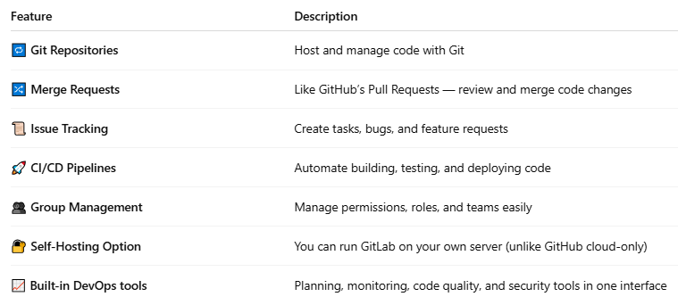

Feature | Description
🔁 Git Repositories | Host and manage code with Git
🔀 Merge Requests | Like GitHub’s Pull Requests — review and merge code changes
📜 Issue Tracking | Create tasks, bugs, and feature requests
🚀 CI/CD Pipelines | Automate building, testing, and deploying code
👥 Group Management | Manage permissions, roles, and teams easily
🔐 Self-Hosting Option | You can run GitLab on your own server (unlike GitHub cloud-only)
📈 Built-in DevOps tools | Planning, monitoring, code quality, and security tools in one interface
Great! Here's a detailed breakdown of each GitLab feature you asked about:

🔁 Git Repositories
# Source: AI Source: Provided by: [Data Path: Persons Table -> ID Column: 1, Name_En Column: Motasem Essam] -> From: [ChatGPT] on [2/16/2026]
A Git repository is where your project's code lives — with its full history.
In GitLab:
- You can create repositories for each project.
- Repos include:
  - All commits (history)
  - Branches (feature or testing versions)
  - Tags (important versions/releases)
- You can clone, pull, push, and fork repositories using Git.
🔧 Example Git commands:
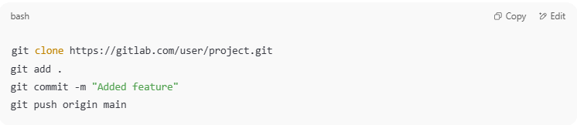
git clone https://gitlab.com/user/project.git
git add .
git commit -m "Added feature"
git push origin main

✅ GitLab gives you a web interface to browse your code and history.

🔀 Merge Requests (MRs)
# Source: AI Source: Provided by: [Data Path: Persons Table -> ID Column: 1, Name_En Column: Motasem Essam] -> From: [ChatGPT] on [2/16/2026]
A Merge Request is GitLab’s version of GitHub’s "Pull Request".
What It Does:
- You propose merging changes from one branch to another.
- GitLab shows:
  - The diff (what changed)
  - Inline comments for code review
  - Approvals required
  - CI pipeline status
Example Workflow:
- Create a branch: feature/login-page
- Make changes and push to GitLab
- Open a Merge Request to main
- Reviewers leave comments or approve
- Merge when it’s ready
✅ MRs allow safe, structured collaboration and review.

📜 Issue Tracking
# Source: AI Source: Provided by: [Data Path: Persons Table -> ID Column: 1, Name_En Column: Motasem Essam] -> From: [ChatGPT] on [2/16/2026]

Issue Tracking is a system for recording, organizing, and managing all types of project tasks — especially:
- 🐞 Bugs (errors in the code)
- ✨ Feature requests
- 🧹 Improvements
- 📋 Tasks or to-dos
It helps teams keep track of what needs to be done, who’s doing it, and what’s already finished.

🧠 In Simple Terms:
Issue Tracking is like a smart to-do list for your project — with team collaboration features.

🔧 Common Elements in an Issue:

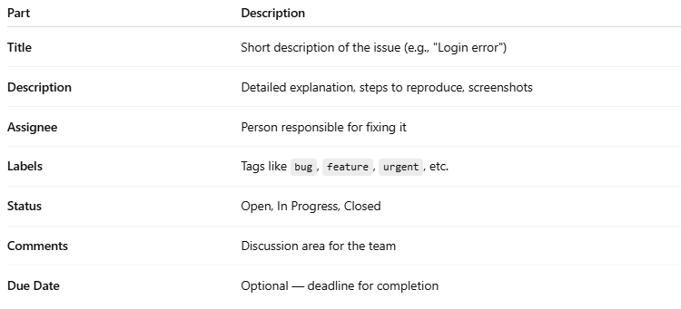

GitLab has a built-in issue tracker to manage:
- Bugs
- Tasks
- Feature requests
- Documentation work
Features:
- Labels, priorities, assignees
- Milestones (group issues by goal or deadline)
- Discussions and file attachments
- Cross-linking with Merge Requests
✅ Each project can have its own set of issues.
🧠 Example: “Bug: Login fails on mobile” — assigned to a developer and linked to a merge request that fixes it.

🔁 Workflow Example
- 🔍 A user reports: “Search button doesn't work”
- A developer creates an issue:
  - Title: “Search button unresponsive”
  - Description: “Clicking the button doesn’t trigger any action...”
  - Labels: bug, UI
- Team discusses it in comments.
- Issue is assigned to a developer.
- Developer fixes it and references the issue in their commit:
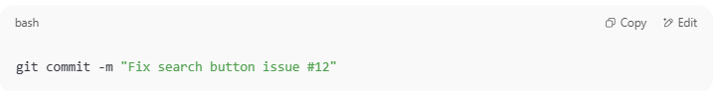
git commit -m "Fix search button issue #12"
- Merge Request closes the issue automatically.
- ✅ Issue status becomes Closed.

📦 Platforms with Issue Tracking
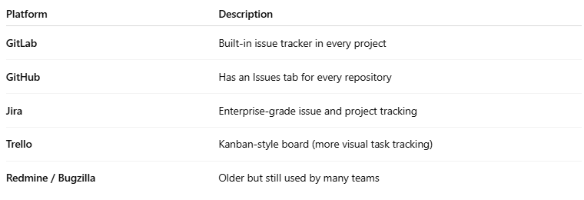

Platform | Description
GitLab | Built-in issue tracker in every project
GitHub | Has an Issues tab for every repository
Jira | Enterprise-grade issue and project tracking
Trello | Kanban-style board (more visual task tracking)
Redmine / Bugzilla | Older but still used by many teams

👁️ GitLab Issue Board
- A drag-and-drop board showing issues in columns (To Do, Doing, Done)
- Can be filtered by label, assignee, or milestone
- Helps visually plan sprints and releases

🧠 Why Issue Tracking Matters
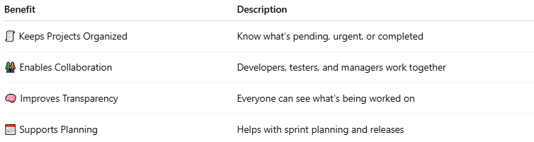

Benefit | Description
🧾 Keeps Projects Organized | Know what’s pending, urgent, or completed
🧑‍🤝‍🧑 Enables Collaboration | Developers, testers, and managers work together
🧠 Improves Transparency | Everyone can see what’s being worked on
📅 Supports Planning | Helps with sprint planning and releases

🚀 CI/CD Pipelines
# Source: AI Source: Provided by: [Data Path: Persons Table -> ID Column: 1, Name_En Column: Motasem Essam] -> From: [ChatGPT] on [2/16/2026]
CI/CD = Continuous Integration / Continuous Deployment
CI/CD Pipelines are automated workflows used in software development to:
- CI (Continuous Integration) — Automatically test and validate code whenever a change is made
- CD (Continuous Delivery/Deployment) — Automatically deliver or deploy that code to servers or production

GitLab has a powerful, built-in automation engine for:
- Building
- Testing
- Deploying your code
Uses .gitlab-ci.yml to define pipelines:
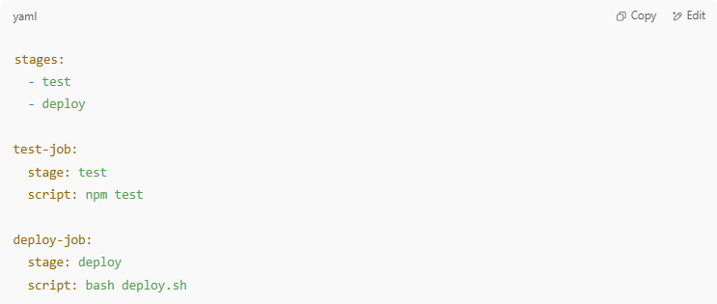
stages:
- test
- deploy

test-job:
stage: test
script: npm test

deploy-job:
stage: deploy
script: bash deploy.sh

✅ Every time you push code:
- GitLab runs the pipeline
- Shows pass/fail per job
- Can deploy your app automatically to staging or production

📦 Common CI/CD Tools
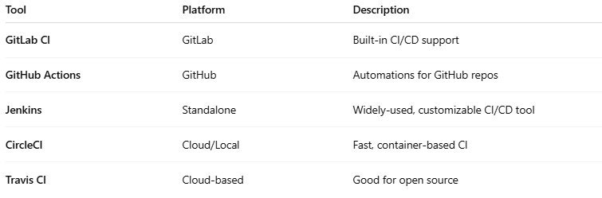

Tool | Platform | Description
GitLab CI | GitLab | Built-in CI/CD support
GitHub Actions | GitHub | Automations for GitHub repos
Jenkins | Standalone | Widely-used, customizable CI/CD tool
CircleCI | Cloud/Local | Fast, container-based CI
Travis CI | Cloud-based | Good for open source

👥 Group Management
# Source: AI Source: Provided by: [Data Path: Persons Table -> ID Column: 1, Name_En Column: Motasem Essam] -> From: [ChatGPT] on [2/16/2026]
GitLab lets you organize people into Groups and Subgroups.
Purpose:
- Manage permissions and access at a team or department level
- Share projects, issues, and pipelines within a group
- Control who can:
  - Push code
  - Merge changes
  - Create new projects
Access Levels:
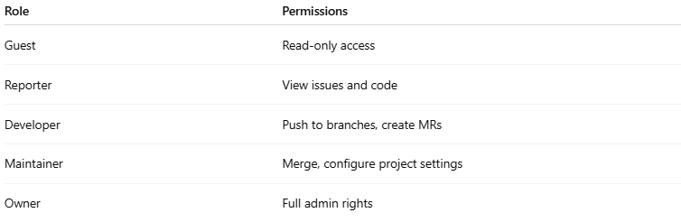

Role | Permissions
Guest | Read-only access
Reporter | View issues and code
Developer | Push to branches, create MRs
Maintainer | Merge, configure project settings
Owner | Full admin rights

🔐 Self-Hosting Option
# Source: AI Source: Provided by: [Data Path: Persons Table -> ID Column: 1, Name_En Column: Motasem Essam] -> From: [ChatGPT] on [2/16/2026]
Unlike GitHub, GitLab can be installed on your own servers.
Benefits:
- Full control of data and access
- Can be used in secure environments (e.g., corporate intranet)
- Customize features and integrations
🧱 GitLab offers:
- Community Edition (Free) – Open-source and self-hostable
- Enterprise Edition (Paid) – Adds advanced features (e.g., compliance, metrics)
✅ Used by banks, enterprises, and governments where privacy is critical.

📈 Built-in DevOps Tools
# Source: AI Source: Provided by: [Data Path: Persons Table -> ID Column: 1, Name_En Column: Motasem Essam] -> From: [ChatGPT] on [2/16/2026]
DevOps is a combination of "Development" + "Operations" — it's a culture, methodology, and set of practices that aim to:
- Break the wall between developers (who write the code) and operations teams (who deploy and maintain it)
- Deliver software faster, more reliably, and with fewer bugs
🧠 In Simple Terms:
DevOps = Developers + IT working together, using automation to:
- Build ✔️
- Test 🧪
- Deploy 🚀
- Monitor 👀
software continuously

🎯 Goals of DevOps
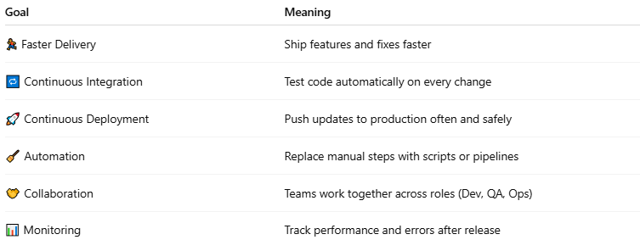

Goal | Meaning
🏃 Faster Delivery | Ship features and fixes faster
🔁 Continuous Integration | Test code automatically on every change
🚀 Continuous Deployment | Push updates to production often and safely
🧹 Automation | Replace manual steps with scripts or pipelines
🤝 Collaboration | Teams work together across roles (Dev, QA, Ops)
📊 Monitoring | Track performance and errors after release

🧰 What Are DevOps Tools?
DevOps tools are software that support the phases of the DevOps lifecycle — from planning to monitoring.

🧭 DevOps Lifecycle Phases & Tools
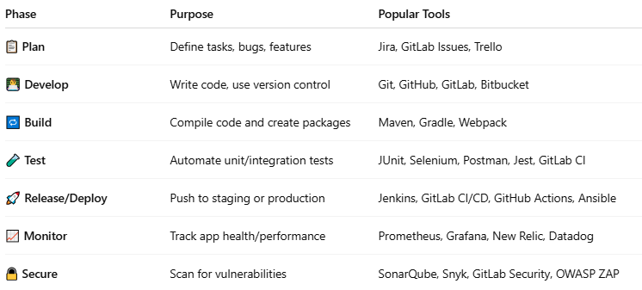

Phase | Purpose | Popular Tools
📋 Plan | Define tasks, bugs, features | Jira, GitLab Issues, Trello
👨‍💻 Develop | Write code, use version control | Git, GitHub, GitLab, Bitbucket
🔁 Build | Compile code and create packages | Maven, Gradle, Webpack
🧪 Test | Automate unit/integration tests | JUnit, Selenium, Postman, Jest, GitLab CI
🚀 Release/Deploy | Push to staging or production | Jenkins, GitLab CI/CD, GitHub Actions, Ansible
📈 Monitor | Track app health/performance | Prometheus, Grafana, New Relic, Datadog
🔒 Secure | Scan for vulnerabilities | SonarQube, Snyk, GitLab Security, OWASP ZAP

🛠 Popular All-in-One DevOps Platforms
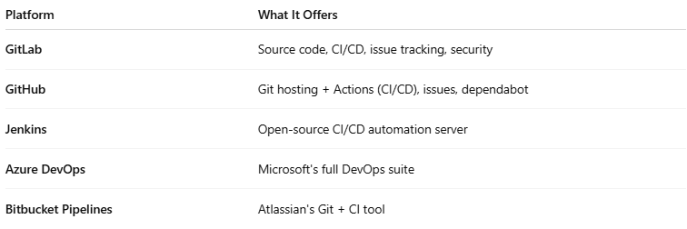

Platform | What It Offers
GitLab | Source code, CI/CD, issue tracking, security
GitHub | Git hosting + Actions (CI/CD), issues, dependabot
Jenkins | Open-source CI/CD automation server
Azure DevOps | Microsoft's full DevOps suite
Bitbucket Pipelines | Atlassian's Git + CI tool

🔄 DevOps vs Traditional Workflow
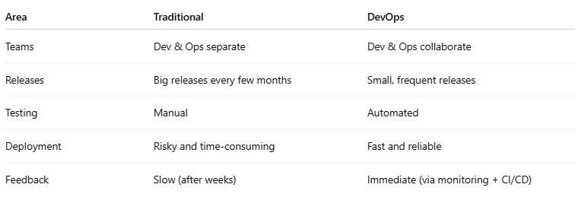

Area | Traditional | DevOps
Teams | Dev & Ops separate | Dev & Ops collaborate
Releases | Big releases every few months | Small, frequent releases
Testing | Manual | Automated
Deployment | Risky and time-consuming | Fast and reliable
Feedback | Slow (after weeks) | Immediate (via monitoring + CI/CD)

GitLab is not just for code — it includes tools for the entire DevOps lifecycle:
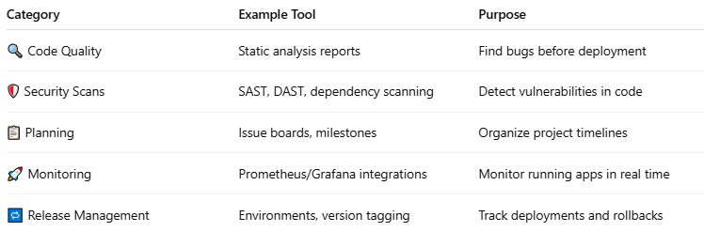

Category | Example Tool | Purpose
🔍 Code Quality | Static analysis reports | Find bugs before deployment
🛡️ Security Scans | SAST, DAST, dependency scanning | Detect vulnerabilities in code
📋 Planning | Issue boards, milestones | Organize project timelines
🚀 Monitoring | Prometheus/Grafana integrations | Monitor running apps in real time
🔁 Release Management | Environments, version tagging | Track deployments and rollbacks
✅ GitLab aims to be an all-in-one DevOps platform — from planning to monitoring.

🔚 Summary
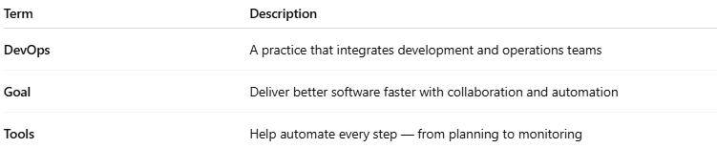

Term | Description
DevOps | A practice that integrates development and operations teams
Goal | Deliver better software faster with collaboration and automation
Tools | Help automate every step — from planning to monitoring

🧠 Summary Table:
# Source: AI Source: Provided by: [Data Path: Persons Table -> ID Column: 1, Name_En Column: Motasem Essam] -> From: [ChatGPT] on [2/16/2026]
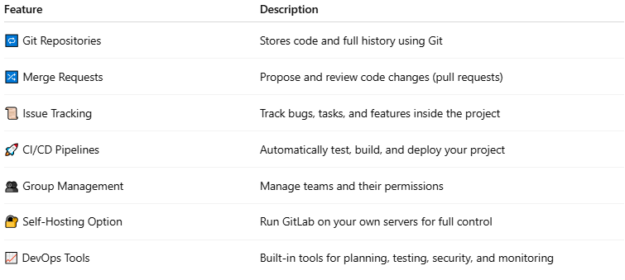
Feature | Description
🔁 Git Repositories | Stores code and full history using Git
🔀 Merge Requests | Propose and review code changes (pull requests)
📜 Issue Tracking | Track bugs, tasks, and features inside the project
🚀 CI/CD Pipelines | Automatically test, build, and deploy your project
👥 Group Management | Manage teams and their permissions
🔐 Self-Hosting Option | Run GitLab on your own servers for full control
📈 DevOps Tools | Built-in tools for planning, testing, security, and monitoring

Would you like to see a live demo using a GitLab .gitlab-ci.yml, or create a small GitLab project?

Git vs GitHub vs GitLab

🔧 Git (the core tool)

Definition
# Source: AI Source: Provided by: [Data Path: Persons Table -> ID Column: 1, Name_En Column: Motasem Essam] -> From: [ChatGPT] on [2/16/2026]
Git is a version control system — software you run locally on your computer.
- Tracks changes in code/files
- Lets you create branches, merge, revert, etc.
- Works offline
- No website/account required
👉 Think of Git as the engine.

When to use Git
# Source: AI Source: Provided by: [Data Path: Persons Table -> ID Column: 1, Name_En Column: Motasem Essam] -> From: [ChatGPT] on [2/16/2026]
Use Git whenever you are writing code or working on files and want version control.
Typical cases:
- You are coding alone and want to track changes
- You want to undo mistakes / go back to older versions
- You work offline
- You manage branches (feature, bugfix, experiment)
👉 Example: Building a small app on your laptop → use Git locally.

🌐 GitHub

Definition
# Source: AI Source: Provided by: [Data Path: Persons Table -> ID Column: 1, Name_En Column: Motasem Essam] -> From: [ChatGPT] on [2/16/2026]
GitHub is a cloud platform that hosts Git repositories.
- Store your Git projects online
- Collaboration (pull requests, issues, code review)
- Huge open-source community
- Integrates with many tools (CI/CD, Actions, apps)
- Owned by Microsoft
👉 Think of GitHub as a social network for code + hosting service.

When to use GitHub
# Source: AI Source: Provided by: [Data Path: Persons Table -> ID Column: 1, Name_En Column: Motasem Essam] -> From: [ChatGPT] on [2/16/2026]
Use GitHub when you need online hosting + collaboration.
Typical cases:
- Working with a team
- Sharing your code publicly (portfolio, open source)
- Contributing to open-source projects
- Using GitHub Actions for basic automation (CI/CD)
- Show your projects to employers
👉 Example: Team project, university assignment, open-source → use Git + GitHub.

🌐 GitLab

Definition
# Source: AI Source: Provided by: [Data Path: Persons Table -> ID Column: 1, Name_En Column: Motasem Essam] -> From: [ChatGPT] on [2/16/2026]
GitLab is also a Git repository hosting platform, but with stronger built-in DevOps tools.
- Everything GitHub does (repos, PRs, issues)
- Powerful built-in CI/CD pipelines
- DevOps lifecycle in one platform (plan → code → build → test → deploy → monitor)
- Can be self-hosted on your own server (very popular in companies)
👉 Think of GitLab as GitHub + full DevOps toolbox.

DevOps Tools
# Source: AI Source: Provided by: [Data Path: Persons Table -> ID Column: 1, Name_En Column: Motasem Essam] -> From: [ChatGPT] on [2/16/2026]
DevOps tools are software tools that help teams automate, monitor, and improve the process of building, testing, and delivering software.
They support the DevOps culture, which focuses on collaboration between development (Dev) and operations (Ops) teams.

Key Categories of DevOps Tools
# Source: AI Source: Provided by: [Data Path: Persons Table -> ID Column: 1, Name_En Column: Motasem Essam] -> From: [ChatGPT] on [2/16/2026]
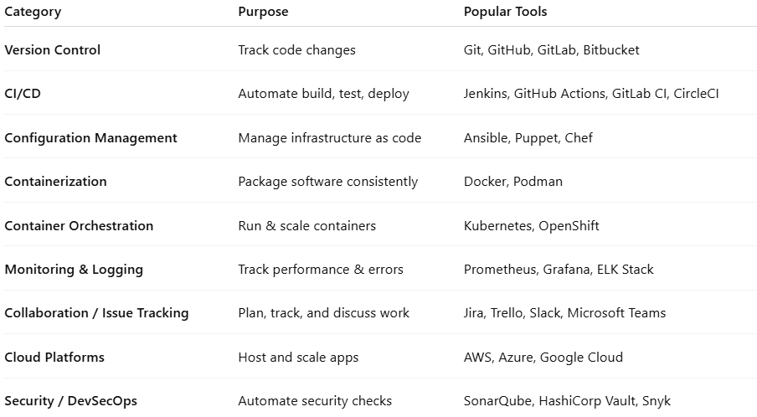
Category | Purpose | Popular Tools
Version Control | Track code changes | Git, GitHub, GitLab, Bitbucket
CI/CD | Automate build, test, deploy | Jenkins, GitHub Actions, GitLab CI, CircleCI
Configuration Management | Manage infrastructure as code | Ansible, Puppet, Chef
Containerization | Package software consistently | Docker, Podman
Container Orchestration | Run & scale containers | Kubernetes, OpenShift
Monitoring & Logging | Track performance & errors | Prometheus, Grafana, ELK Stack
Collaboration / Issue Tracking | Plan, track, and discuss work | Jira, Trello, Slack, Microsoft Teams
Cloud Platforms | Host and scale apps | AWS, Azure, Google Cloud
Security / DevSecOps | Automate security checks | SonarQube, HashiCorp Vault, Snyk

Why DevOps Tools Are Important
# Source: AI Source: Provided by: [Data Path: Persons Table -> ID Column: 1, Name_En Column: Motasem Essam] -> From: [ChatGPT] on [2/16/2026]
- Automation – reduce repetitive manual tasks
- Collaboration – Dev + Ops work together seamlessly
- Faster delivery – code moves from development to production quickly
- Reliability – testing, monitoring, and rollback tools make deployments safer
- Scalability – tools like Kubernetes and cloud platforms handle growth

Analogy
# Source: AI Source: Provided by: [Data Path: Persons Table -> ID Column: 1, Name_En Column: Motasem Essam] -> From: [ChatGPT] on [2/16/2026]
- DevOps tools = factory machines and sensors
- Developers = workers making the product
- Operations = managing the assembly line & delivery
- Tools automate, monitor, and ensure quality

💡 Memory trick:
# Source: AI Source: Provided by: [Data Path: Persons Table -> ID Column: 1, Name_En Column: Motasem Essam] -> From: [ChatGPT] on [2/16/2026]
DevOps tools = everything you need to build, test, deploy, and monitor software reliably and fast

CI/CD Pipelines
# Source: AI Source: Provided by: [Data Path: Persons Table -> ID Column: 1, Name_En Column: Motasem Essam] -> From: [ChatGPT] on [2/16/2026]
CI/CD pipelines are a set of automated steps that build, test, and deploy software.
They are widely used in DevOps to make sure that code changes are safe, tested, and delivered quickly.

What CI/CD stands for
# Source: AI Source: Provided by: [Data Path: Persons Table -> ID Column: 1, Name_En Column: Motasem Essam] -> From: [ChatGPT] on [2/16/2026]
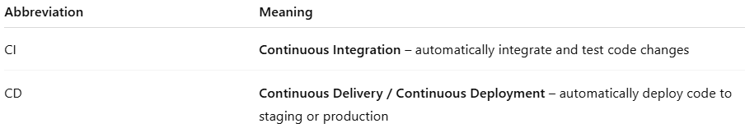
Abbreviation | Meaning
CI | Continuous Integration – automatically integrate and test code changes
CD | Continuous Delivery / Continuous Deployment – automatically deploy code to staging or production

1. Continuous Integration (CI)
# Source: AI Source: Provided by: [Data Path: Persons Table -> ID Column: 1, Name_En Column: Motasem Essam] -> From: [ChatGPT] on [2/16/2026]
- Developers push code frequently to a shared repository
- CI systems automatically build and test the code
- Detects bugs early before they reach production
Steps in CI:
- Code is pushed → triggers CI
- Build the application
- Run automated tests
- Report results
Popular CI tools:
- Jenkins
- GitHub Actions
- GitLab CI

2. Continuous Delivery / Deployment (CD)
# Source: AI Source: Provided by: [Data Path: Persons Table -> ID Column: 1, Name_En Column: Motasem Essam] -> From: [ChatGPT] on [2/16/2026]
- After CI passes, CD automates deployment
- Continuous Delivery: deploys to staging, humans approve production deployment
- Continuous Deployment: deploys automatically to production if all tests pass
Steps in CD:
- Take CI-approved code
- Deploy to staging/testing environment
- Run additional tests
- Deploy to production automatically (or manually if delivery)

Example CI/CD Pipeline
# Source: AI Source: Provided by: [Data Path: Persons Table -> ID Column: 1, Name_En Column: Motasem Essam] -> From: [ChatGPT] on [2/16/2026]
Code pushed → CI triggers → Build → Test → Deploy to staging → Approve → Deploy to production
- Automates repetitive tasks
- Reduces human errors
- Speeds up software delivery

Analogy
# Source: AI Source: Provided by: [Data Path: Persons Table -> ID Column: 1, Name_En Column: Motasem Essam] -> From: [ChatGPT] on [2/16/2026]
- Think of CI/CD like a factory assembly line:
  - Raw material = your code
  - Machines = automated build & test
  - Finished product = tested software deployed safely

💡 Memory trick:
# Source: AI Source: Provided by: [Data Path: Persons Table -> ID Column: 1, Name_En Column: Motasem Essam] -> From: [ChatGPT] on [2/16/2026]
CI = integrate & test continuously
CD = deliver or deploy continuously

When to use GitLab
# Source: AI Source: Provided by: [Data Path: Persons Table -> ID Column: 1, Name_En Column: Motasem Essam] -> From: [ChatGPT] on [2/16/2026]
Use GitLab when you need full DevOps + strong automation.
Typical cases:
- You want powerful built-in CI/CD pipelines
- Your company needs private self-hosted Git server
- You manage full lifecycle (plan → build → test → deploy)
- Enterprise / professional DevOps environments
👉 Example: Company project with automated testing & deployment → use Git + GitLab.

⚡ Quick Comparison
# Source: AI Source: Provided by: [Data Path: Persons Table -> ID Column: 1, Name_En Column: Motasem Essam] -> From: [ChatGPT] on [2/16/2026]
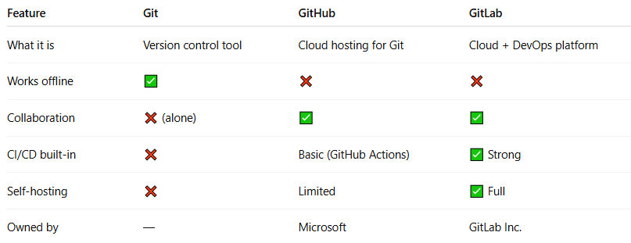
Feature | Git | GitHub | GitLab
What it is | Version control tool | Cloud hosting for Git | Cloud + DevOps platform
Works offline | ✅ | ❌ | ❌
Collaboration | ❌ (alone) | ✅ | ✅
CI/CD built-in | ❌ | Basic (GitHub Actions) | ✅ Strong
Self-hosting | ❌ | Limited | ✅ Full
Owned by | — | Microsoft | GitLab Inc.

🧠 Simple analogy
# Source: AI Source: Provided by: [Data Path: Persons Table -> ID Column: 1, Name_En Column: Motasem Essam] -> From: [ChatGPT] on [2/16/2026]
- Git = Camera (records history)
- GitHub = Instagram (share & collaborate)
- GitLab = Instagram + Photoshop studio + automation factory

Git and GitHub and GitLab has different commands
# Source: AI Source: Provided by: [Data Path: Persons Table -> ID Column: 1, Name_En Column: Motasem Essam] -> From: [ChatGPT] on [2/16/2026]
Yes — Git and GitHub and GitLab have different commands, but it depends on whether you are talking about core Git commands or platform-specific commands. Let me clarify carefully.

core Git commands
# Source: AI Source: Provided by: [Data Path: Persons Table -> ID Column: 1, Name_En Column: Motasem Essam] -> From: [ChatGPT] on [2/16/2026]
GitHub, and GitLab use the same Git commands.
Here’s the breakdown:

1. Git commands are the same everywhere
# Source: AI Source: Provided by: [Data Path: Persons Table -> ID Column: 1, Name_En Column: Motasem Essam] -> From: [ChatGPT] on [2/16/2026]
Whether your repository is:
- Local only (just Git)
- Hosted on GitHub
- Hosted on GitLab
…the core commands like git commit, git push, git pull, git branch, git merge work the same way.
Examples:
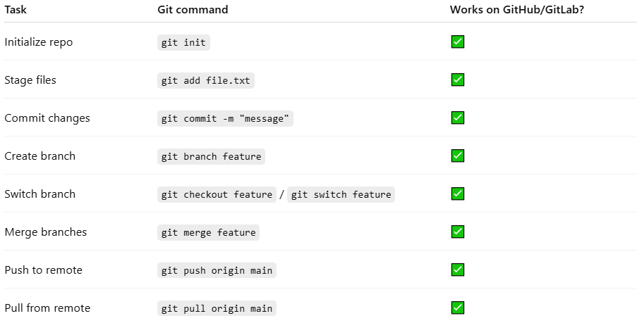
Task | Git command | Works on GitHub/GitLab?
Initialize repo | git init | ✅
Stage files | git add file.txt | ✅
Commit changes | git commit -m "message" | ✅
Create branch | git branch feature | ✅
Switch branch | git checkout feature / git switch feature | ✅
Merge branches | git merge feature | ✅
Push to remote | git push origin main | ✅
Pull from remote | git pull origin main | ✅

2. What differs is the remote URL
# Source: AI Source: Provided by: [Data Path: Persons Table -> ID Column: 1, Name_En Column: Motasem Essam] -> From: [ChatGPT] on [2/16/2026]
- GitHub: git remote add origin git@github.com:user/repo.git
- GitLab: git remote add origin git@gitlab.com:user/repo.git
Other than that, Git commands themselves do not change.

✅ Key point
# Source: AI Source: Provided by: [Data Path: Persons Table -> ID Column: 1, Name_En Column: Motasem Essam] -> From: [ChatGPT] on [2/16/2026]
Core Git commands are platform-independent.
GitHub and GitLab don’t change Git commands, they just host your remote repository and add features like Pull Requests (GitHub) / Merge Requests (GitLab), CI/CD, etc.

💡 Memory trick:
# Source: AI Source: Provided by: [Data Path: Persons Table -> ID Column: 1, Name_En Column: Motasem Essam] -> From: [ChatGPT] on [2/16/2026]
- Git = core engine → commands never change
- GitHub/GitLab = remote storage + extra features → Git commands stay the same

platform-specific commands
# Source: AI Source: Provided by: [Data Path: Persons Table -> ID Column: 1, Name_En Column: Motasem Essam] -> From: [ChatGPT] on [2/16/2026]
platform-specific commands are extra commands GitHub and GitLab provide beyond core Git.

1. GitHub platform-specific commands
# Source: AI Source: Provided by: [Data Path: Persons Table -> ID Column: 1, Name_En Column: Motasem Essam] -> From: [ChatGPT] on [2/16/2026]
GitHub provides GitHub CLI (gh) for actions you usually do on the web:
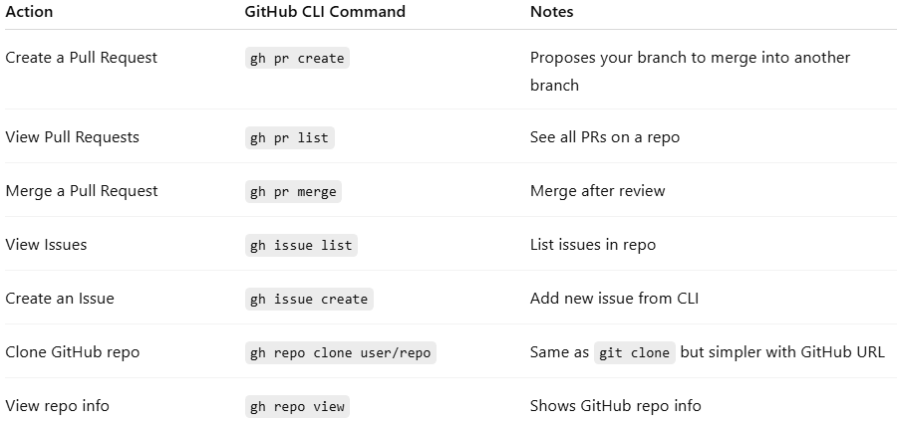
Action | GitHub CLI Command | Notes
Create a Pull Request | gh pr create | Proposes your branch to merge into another branch
View Pull Requests | gh pr list | See all PRs on a repo
Merge a Pull Request | gh pr merge | Merge after review
View Issues | gh issue list | List issues in repo
Create an Issue | gh issue create | Add new issue from CLI
Clone GitHub repo | gh repo clone user/repo | Same as git clone but simpler with GitHub URL
View repo info | gh repo view | Shows GitHub repo info
Key idea:
- These commands interact with GitHub features like PRs, Issues, Actions, not core Git commits.
- You still use normal Git commands to commit, branch, merge, push, pull, etc.

2. GitLab platform-specific commands
# Source: AI Source: Provided by: [Data Path: Persons Table -> ID Column: 1, Name_En Column: Motasem Essam] -> From: [ChatGPT] on [2/16/2026]
GitLab provides GitLab CLI (glab) for GitLab-specific actions:
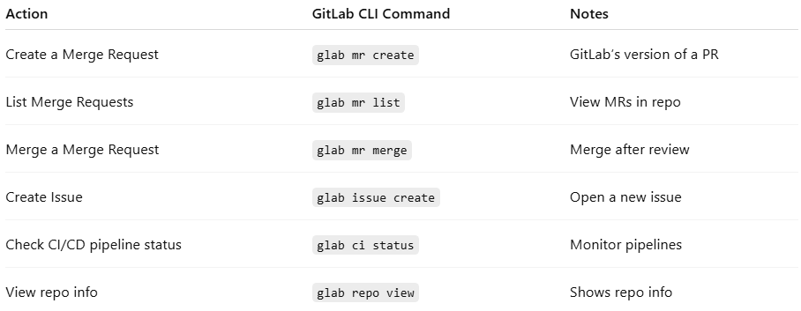
Action | GitLab CLI Command | Notes
Create a Merge Request | glab mr create | GitLab’s version of a PR
List Merge Requests | glab mr list | View MRs in repo
Merge a Merge Request | glab mr merge | Merge after review
Create Issue | glab issue create | Open a new issue
Check CI/CD pipeline status | glab ci status | Monitor pipelines
View repo info | glab repo view | Shows repo info
Key idea:
- These commands interact with GitLab features like MRs, issues, CI/CD pipelines, not the Git commit history.

3. Comparison: GitHub vs GitLab
# Source: AI Source: Provided by: [Data Path: Persons Table -> ID Column: 1, Name_En Column: Motasem Essam] -> From: [ChatGPT] on [2/16/2026]
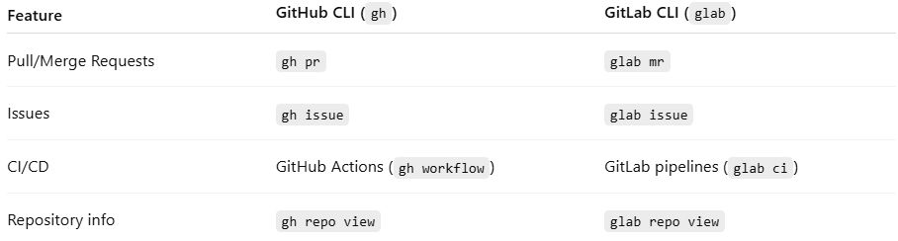
Feature | GitHub CLI (gh) | GitLab CLI (glab)
Pull/Merge Requests | gh pr | glab mr
Issues | gh issue | glab issue
CI/CD | GitHub Actions (gh workflow) | GitLab pipelines (glab ci)
Repository info | gh repo view | glab repo view

✅ Key points
# Source: AI Source: Provided by: [Data Path: Persons Table -> ID Column: 1, Name_En Column: Motasem Essam] -> From: [ChatGPT] on [2/16/2026]
- Core Git commands are the same everywhere.
- Platform-specific commands exist only for GitHub/GitLab features, not for committing or branching.
- GitHub uses gh CLI, GitLab uses glab CLI.
- These make Pull Requests / Merge Requests / CI/CD / Issues manageable from the terminal.

💡 Memory trick:
# Source: AI Source: Provided by: [Data Path: Persons Table -> ID Column: 1, Name_En Column: Motasem Essam] -> From: [ChatGPT] on [2/16/2026]
Git = engine
GitHub CLI (gh) = control GitHub features
GitLab CLI (glab) = control GitLab features

🛠 GitLab CI/CD Example (simple .gitlab-ci.yml):
# Source: AI Source: Provided by: [Data Path: Persons Table -> ID Column: 1, Name_En Column: Motasem Essam] -> From: [ChatGPT] on [2/16/2026]
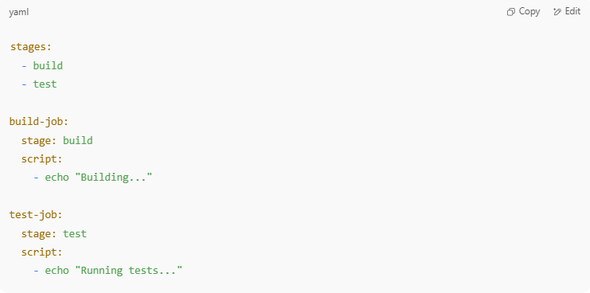

stages:
- build
- test

build-job:
stage: build
script:
- echo "Building..."

test-job:
stage: test
script:
- echo "Running tests..."

This file tells GitLab to build and test your project automatically on every push.

✅ Common Use Cases
# Source: AI Source: Provided by: [Data Path: Persons Table -> ID Column: 1, Name_En Column: Motasem Essam] -> From: [ChatGPT] on [2/16/2026]
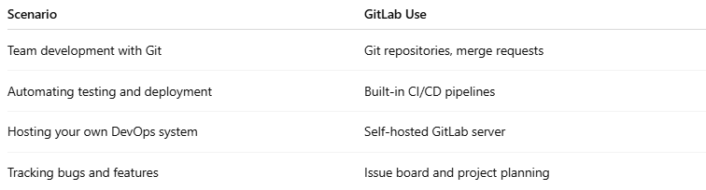

Scenario | GitLab Use
Team development with Git | Git repositories, merge requests
Automating testing and deployment | Built-in CI/CD pipelines
Hosting your own DevOps system | Self-hosted GitLab server
Tracking bugs and features | Issue board and project planning

🔚 Summary
# Source: AI Source: Provided by: [Data Path: Persons Table -> ID Column: 1, Name_En Column: Motasem Essam] -> From: [ChatGPT] on [2/16/2026]
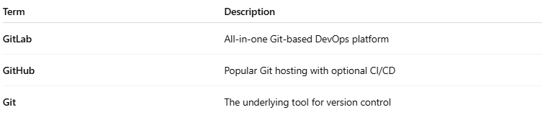

Term | Description
GitLab | All-in-one Git-based DevOps platform
GitHub | Popular Git hosting with optional CI/CD
Git | The underlying tool for version control

